**CENTRAL COLLEGE KAWEMPE**

**End of year assessment**

**Senior one physics**

**Time, 1 hour and 15mins**

**Answer all questions**

**1 All primary pupils cannot give a difference between temperature and heat ,as a senior one student give a difference between temperature and heat**

1. **Thermometers measure temperature in different units**

**I) State the units in which temperature is measured**

**C Jane was suffering from malaria and she went to a hospital , the doctor**

**measured her temperature and found out that it was 38.2⁰C ,**

**Calculate Jane's temperature in**

1. **In Kelvin**
2. **In ⁰F**

D water is not normally used in thermometers

I ) State the reason why water is not used in thermometers

1. If water is not used in thermometers,then which liquids do you think are suitable for use in thermometers
2. State the advantages of using one of the above liquids over the other

2 a) Weight and mass are two measurable quantities in physics,as a senior one physics student, explain how you can differentiate between weight and mass

1. If you are to measure both mass and weight ,which instruments can you use to measure both weight and mass
2. After measuring her weight, Jane found out that she has a mass of 50kg ,
3. Find Jane's weight

There exists many types of force that act on objects on planet earth

1. Define the term force
2. Give any five types of forces that exist on the earth

The table below shows numerical values of different parameters of physics, complete the table by writing the numerical values in standard form

|  |  |
| --- | --- |
| Parameters | Standard form |
|  |  |
|  |  |
|  |  |

4 Two students Tronna and Glen were task to measure the length of their classroom , Glen used his footsteps and got 20 footsteps while Tronna went to the laboratory and got tape measure,she found out that the length of the class was 5meters

1. Why did the two students get different values of the length

Who of two students got the collect measurements of the class

How can you improve on the accuracy of an estimated value

5 While in village you went to fetch water however your sister saw an insect walking on water surface and she was surprised and thought it was magic

1. Tell your sister which type of force enables insect to float on water
2. Suppose you are in your school and given the following apparatus;beaker water, needle and filter paper, describe how you can show the existence of this type of force on water surface

6 While Jane was preparing tea, she put a spoon into the hot tea for stirring, after sometime the spoon was too hot to handle with bare hands

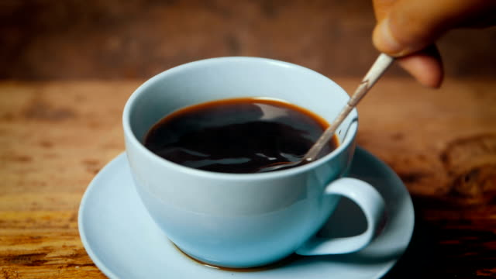

Task

Write a speech explaining how heat moved through the molecule of the spoon to Jane's hands

8 You are provided with the following materials plastic, copper,water, aluminium and rubber

1. Group the following materials into conductors and insulators
2. During your physics lesson in a topic "Calibration of a thermometer" your friends wanted to use water as a thermometric liquid but you advised them that water may not be a good liquid to use because it is a poor conductor of heat.Given the following apparatus glass tube, ice cubes water burnsen burner and wire gauze , describe an experiment 🧪 you can use to convince your friends that water is a poor conductor of heat

9 Your class monitor always encourages you to sweep the classroom very early in the morning claiming that at early morning, the dust in the does not spread in the classroom, he complains whenever you sweep the classroom at lunch time and in the evening saying that the dust is too much at that time

1. Why do you think the dust spreads too much at lunch than evening and the morning time
2. Which process so you think is occurring when the dust spreads as you are sweeping the classroom
3. State the factors that affect the process in (a)
4. If you are in your school science laboratory how can you demonstrate the process above (B) using relevant apparatus

***END ****